**Guidelines for Biomarker Data Collection Using Computer**

**Assisted Personal Interview (CAPI)**

**DHS Demographic and Health Surveys**

**TABLE OF CONTENTS**

INTRODUCTION 3

1 COLLECTING BIOMARKER DATA BY HEALTH SPECALISTS 4

1.1 Introduction 4

1.2 Starting the Biomarker data registration 5

1.3 Confirming Supervisor and Health Specialists Codes and Cluster Number 8

1.4 Biomarker Menu 9

1.5 Data exchange between Interviewers and Health specialist and 9

1.6 Identifying individuals eligible for Biomarkers 12

1.7 Registering biomarker data according to individuals 14

1.8 Transferring biomarker data to supervisors 19

1.9 Receive system upgrades from supervisor 22

1.10 Modify identifiers or delete individuals 23

1.10 Changing cluster number and exiting the system 26

2. COLLECTING BIOMARKER USING PAPER QUESTIONNAIRES 28

2.1 Introduction 28

2.2 Entering biomarker questionnaires 28

2.3 List eligible individuals/Biomarkers 32

3. COLLECTING BIOMARKER DATA BY INTERVIEWERS 35

3.1 Introduction 35

3.2 List eligible individuals/Biomarkers 35

3.3 Entering biomarker data 36

# INTRODUCTION

This document introduces the major operations of the computer assisted personal interviews (CAPI) in the Demographic and Health Survey (DHS) for collecting data for biomarkers. The document explains the roles and responsibilities of interviewers, supervisors and health specialists in collecting biomarker data for DHS surveys.

There are three models or approaches to collect data for biomarkers in a DHS CAPI operation: 1-The first model is used when health specialists are designated to collect biomarkers and directly enter the data into tablet computers concurrently with the measurment/collection of the biomarkers. 2-The second model is used when health specialists use a biomarker paper questionnaire to collect/register the biomarkers. After the data is collected on the paper questionnaire, health specialists hand over the questionnaires to interviewers and they in turn enter the data in the field into their own tablets. 3-The third model, is used when Interviewers themselves collect the biomarkers and simulatenously enter the data in their tablet computers. In the past most of the DHS surveys have been carried out using the second model or approach. The third model have been used in a few surveys. The first model hasn’t been used up to date, but it is expected to be the model to be recommended by DHS. As a result, the bulk of this document is devoted to describe the first approach. However, the document also discuss the implmentation of the two other models.

Users of this document are erncouraged to read the first two sections of the CAPI Interviwer’s Manual. Section one in that manual provides information on the use of tablet computers and section 2 describes some general information about CSPro characteristics important for the implmentation of CAPI data collection applications.

# COLLECTING BIOMARKER DATA BY HEALTH SPECALISTS

## 1.1 Introduction

With this approach health specialists are designated to collect and enter biomarker data into tablets provided to them. In general, one health specialist is assigned to a fieldwork team. Interviewers in the fieldworker team collect household data and transfer them to the health specialist. Health specialists are provided with a system to identify eligible individuals for biomarkers in the households collected by interviewers and to register the biomarker data on their tablets. After collecting biomarkers health specialists transfer the data to their supervisors. Supervisors in turn are provided with tools to consolidate and make sure that no biomarkers are missing.

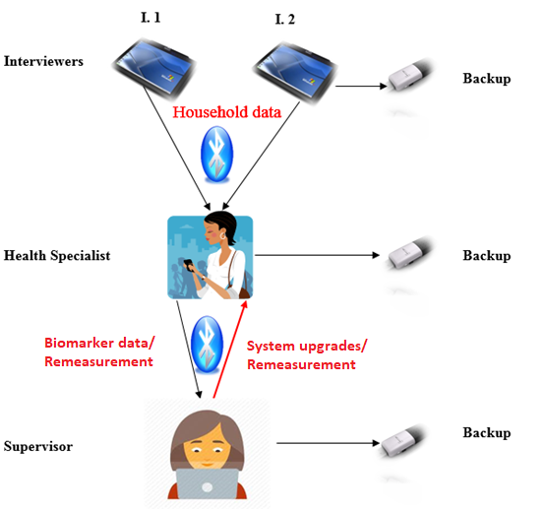

## 1.2 Starting the Biomarker data registration

The biomarker data collection application is based on a menu system that allows health specialists to perform all the tasks required to record and follow-up on the biomarkers to be collected for the survey. These are the steps necessary to access the menu system.

* Make sure you are logged into Windows and are able to see the Windows Desktop on your tablet.
* Double click on the Biomarker’s data collection system icon on the Windows Desktop. The icon bears a resemblance of a health specialist and it has as its title the text “BIOMARKERS”. The start screen for the biomarker system is displayed after a few moments.



The Biomarker system will ask you to complete or confirm three important pieces of information for authentication purposes. These are, in the order they are asked:

1. Your supervisor code

2. Your health specialist code

3. The number of the cluster where you are working with

The cursor starts in the field with the label “Introduction” and in the area for questions a welcome introduction is displayed followed by an instruction to “Press any key to continue”. As recommended (in the interviewer’s manual) press the enter or space bar keys any time that the instruction “Press any key” is requested by the system. The cursor then moves to the supervisor field and prompts to select the name of your supervisor. Once the supervisor name is selected the cursor moves to the interviewer’s name and prompts to select your health specialist name/code. To select your supervisor name as well as your name, click on the small circle next to the corresponding name, you can also type your supervisor or health specialist code number. The system then requests to enter the cluster number where you are working. As described in the introduction of the interviewer’s manual your health specialist code and name are stored in the “Fieldworker personnel” file. The valid clusters are stored in the “Clusters” file. By entering the cluster number, the system knows all geographical variables associated to the cluster.

Step by step this is how the information is requested:

1. After pressing the enter/space bar key in the introduction field, the system asks to select your supervisor from a list of survey supervisors

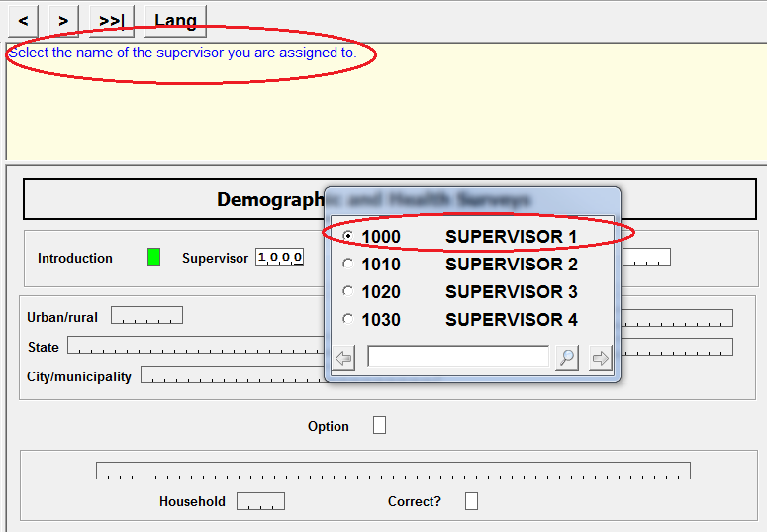

1. In a similar manner after entering the supervisor name, the system requests to select your name. In most DHS surveys, there is only one health specialist assigned to each fieldworker team, therefore only the name of the health specialist assigned to the team is displayed.

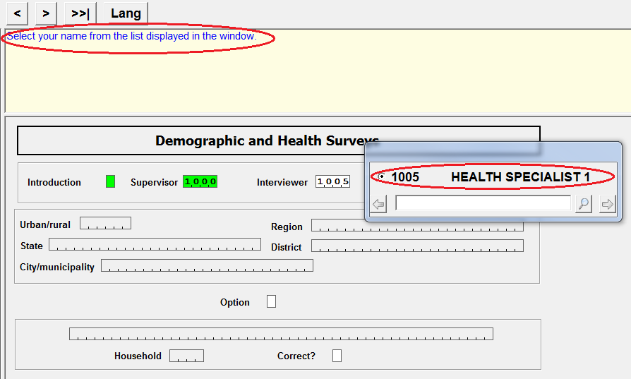

1. You will then be requested to enter the cluster number for the households where biomarkers are collected. The cluster number must be entered using the keyboard.

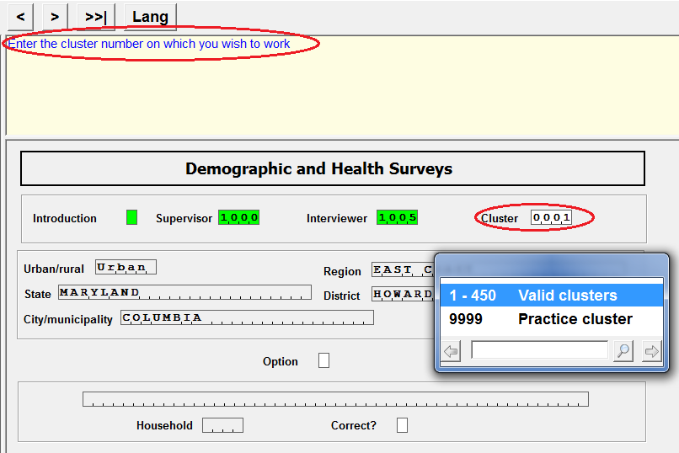

1. After entering the cluster number, the CAPI system displays the geographical variables associated to the cluster and the cursor moves to the “Option” field. At this point, the system is ready to display the main menu for Biomarkers.

Please make sure that the information provided in the questions area (health specialist name, supervisor name and cluster number are correct) and that the geographical information displayed in the form corresponds to the cluster you are working in.

After the cursor reaches the option field it is waiting for you to press any key to display the menu. Press the **next** button , or the enter key or the spacebar key on the keyboard and the Main Menu for the Biomarker system is displayed.

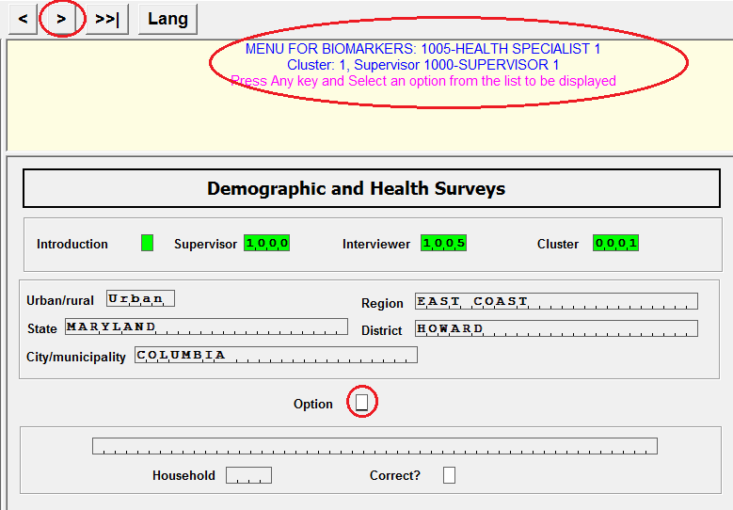

## 1.3 Confirming Supervisor and Health Specialists Codes and Cluster Number

After the Biomarker system is executed for the first time, the system stores the supervisor and health specialist code and the cluster number that is used for that data collection session. In subsequent executions of the system, it uploads that information and automatically prepopulate those fields with the known values used in the previous session. This is done for your convenience, to avoid the need to re-enter each of these items every time the menu is executed. However, you must **confirm** that each item is correct before continuing to the main menu. Special attention should be taken when moving from one cluster to another as the cluster number needs to be changed.

To confirm the supervisor and health specialist codes and the cluster number, you can do either of the following actions:

- click on the button  at the top left hand of the screen

- use the “Enter” key on the keyboard.

Performing either action will confirm that the item is correct, and the Biomarker system will move on to the next item.

|  |  |
| --- | --- |
| **C:\Users\21701\AppData\Local\Microsoft\Windows\Temporary Internet Files\Content.IE5\EM0L2KO6\MC900442128[1].png** | When starting work in a new cluster, make sure to **change** the cluster number to the new cluster where biomarkers will be collected. This is important as the system is not capable of performing any of the tasks associated to Biomarker data collection, if the cluster isn’t correct. |

## 1.4 Biomarker Menu

The Biomarker system uses a menu to execute all possible tasks that are needed for health specialists to register biomarker data.

To start their work in a cluster, health specialists need to identify the individuals that are eligible for biomarkers in households selected for the survey in the cluster. Since household data are collected by interviewers in the team, interviewers must transfer the data to health specialists. Actually, interviewers transfer both household and individual data. The reason to transfer individual questionnaires is because according to DHS procedures, biomarkers should be taken only after all eligible individuals questionnaires are completed. It is possible that a household has more than one eligible individual. Individual questionnaires are particularly important for biomarkers for children because the children’s date of birth is a critical piece of information. The most reliable date of birth for children is collected in the birth history in the individual questionnaire.

## 1.5 Data exchange between Interviewers and Health specialist and

The first option in the Biomarker data collection system is to receive data from interviewers. None of the options in the menu can be executed unless at least one household had been sent to the health specialist by any of the interviewers in the team. There are several ways that an option in the menu can be selected/executed.

* By typing the option number (in this case the number 1) using the tablet keyboard
* By taping in the in the option using the tablet mouse, stylus, or just the finger
* By moving up and down with the tablet’s arrow keys and pressing the enter key once the cursor highlights the desired option

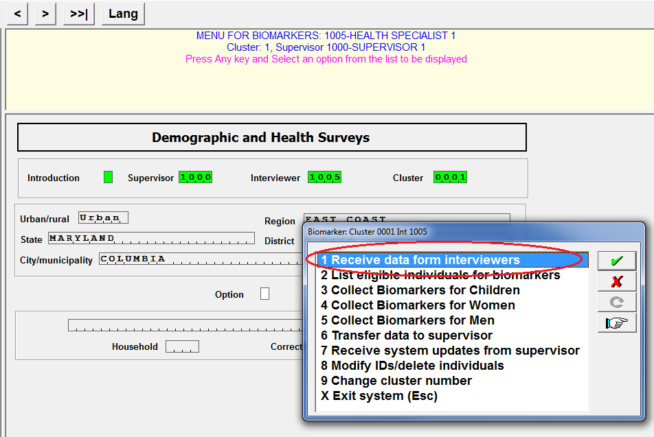

After selecting option “**1-Receive data from interviewers**), the system activates the tablet Bluetooth device and waits in listening mode until one or more of the interviewers send data.

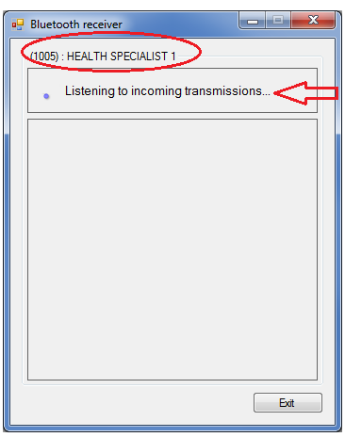

On the other hand, interviewers are provided with the capability to send data to health specialists. In order for interviewers to do that, using their system they select in the main menu option “**A-Data exchange/other utilities”** and in the transfer submenu they select option “**8-Transfer data to Biomarker specialist**”.

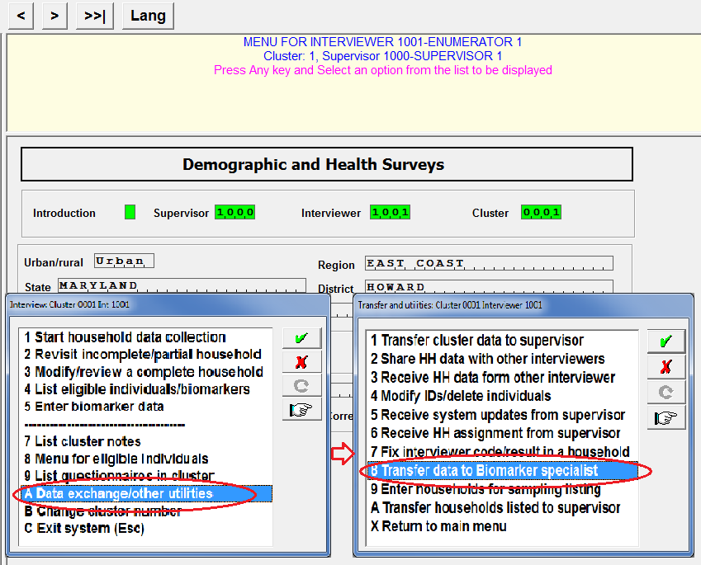

It is important to highlight that the supervisor as well as the cluster number should be the same in both the Biomarker and the interviewers’ data collection systems. If they are not, the transferring of the data does not work at all. After interviewers select option A in the main menu followed by option 8 in the transfer menu, the interviewer’s tablet activates the Bluetooth device and begins to search for the health specialist assigned to the team. Note that in this particular case “**INTERVIEWER 1**” is searching for “**HEALTH SPECIALIST 1**”. Once the health specialist tablet is found by the interviewer’s tablet, the row with the name of the health specialist gets green and the data is transferred. After the data is transferred the window shown below in the interviewer tablet closes automatically. Similarly, when the health specialist receives the data the window displayed in her/his machine closes automatically.

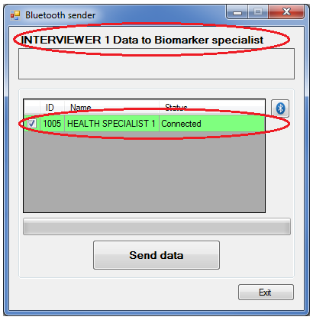

If the interviewer’s tablet is unable to locate the health specialist tablet, instead of green the row with the name of the health specialist gets red. At that point, the interviewer should release the window with the exit button and the operation has to be repeated. As with any operations involving Bluetooth, the parties involved in the data exchange (interviewers and health specialist) should be within 30 feet (10 meters) of each other. It is also important to note that only members of the same team and only individuals designated as health specialist within the team are allowed by the system to receive data as part of this operation.

## 1.6 Identifying individuals eligible for Biomarkers

After health specialists receive data from interviewers, they can list the individuals in the cluster that are eligible for biomarkers. To do that, health specialists select option “**2-List eligible individuals for biomarkers**” from the menu. At that point, the system analyzes the data sent by all interviewers in the team and displays a report

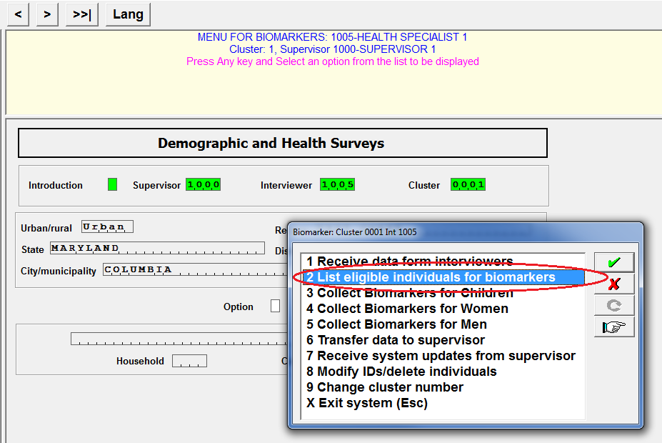

After selecting option 2, the system analyzes the data sent by all interviewers in the team and displays a report like this one.

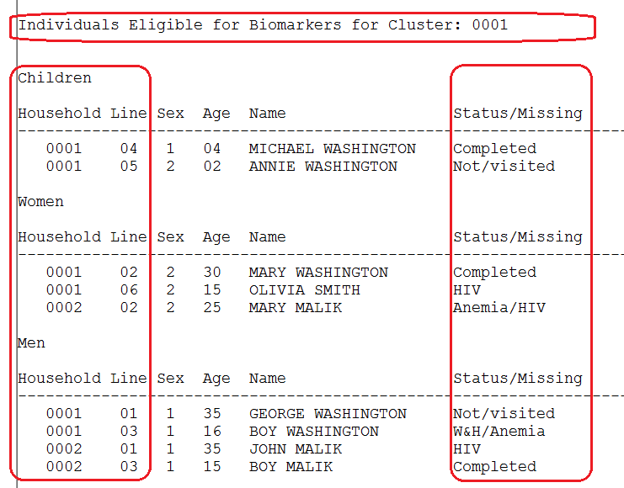

The report shows the household number, line number of the individual in the household schedule, sex, age and name for eligible individuals in the cluster. The characteristics are first displayed for children and followed by women and men. In this particular report the health specialist has received data for households 0001 and 0002 in cluster 0001. The households may have come from the same or different interviewers. The report also displays information to keep track of the status of the biomarkers for every individual. To know the status of the biomarkers collected for each individual it is important to understand how to interpret then report column “**Status/Missing**”:

* **Completed**, means that all biomarkers for that individual have been recorded
* **Not/visited**, means that none of the biomarkers have been collected for the individual
* The name of a biomarker or combination of them means that those biomarkers still need to be collected individual. The standard DHS biomarkers are: **W&H for** Height and weight, **Anemia,** and **HIV.** However, the application should be adapted to add or delete biomarkers according to the survey requirements.

In the report above, all biomarkers were already collected for Michael Washington, Mary Washington and Boy Malik. No biomarkers have been collected for Annie Washington and George Washington. Anemia needs to be collected for Mary Malik and Boy Washington. HIV needs to be collected for Olivia Smith and John Malik. Height and weight has to be collected for Boy Washington. After analyzing the report, the screen should be dismissed with the  button in the upper right corner.

## 1.7 Registering biomarker data according to individuals

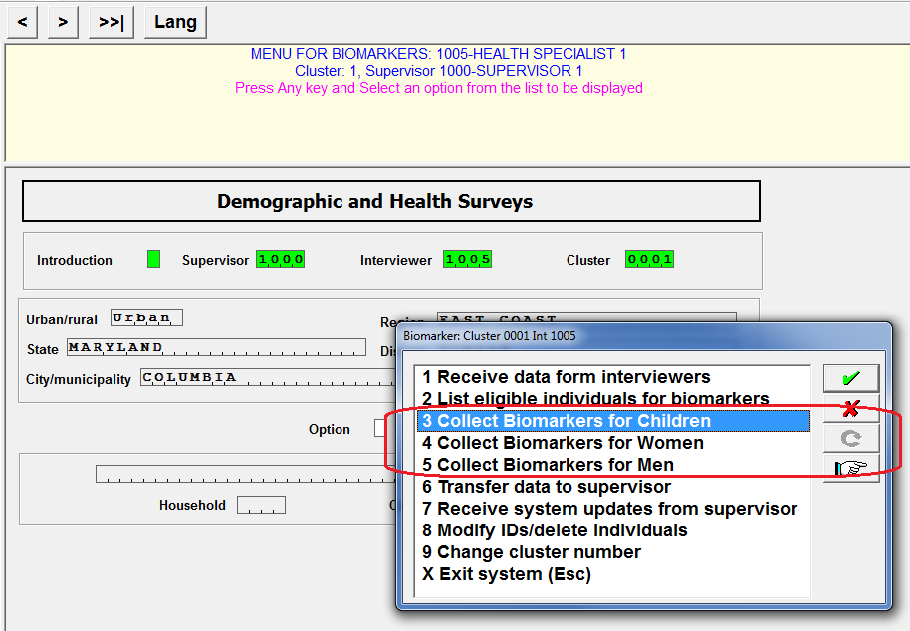

Options 3, 4, and 5 are used to register the biomarker data for Children, Women and Men respectively. There are a few reasons to split the data collection into three rather than just one option:

* Not all eligible individuals are tested for the same biomarkers. For example, in DHS surveys children are not normally tested for HIV
* Depending on subsampling selection, there could be a large number of individuals to be tested for Biomarkers in a cluster. By splitting them the number to be displayed for selection is reduced by approximately one third
* To follow the design of the DHS Biomarker questionnaire which has three different sections, one for each one of the individuals

Upon selecting one of these options, the system automatically displays the same report described in the previous section. This is done to remind health specialists of the status of the biomarkers for the each individual eligible. After dismissing the report, the system will display a list of individuals available for Biomarkers according to the option selected. For example, if option 5 is selected, the system displays the following window:

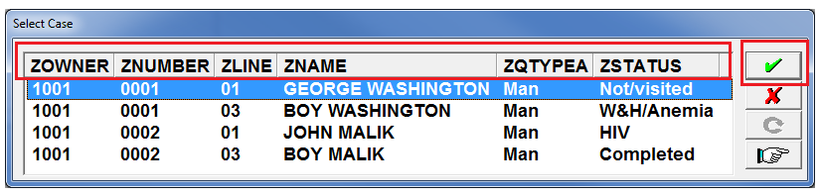

The information displayed in the window corresponds to:

* ZOWNER – The code of the interviewer that collected that household
* ZNUMBER – The household number
* ZLINE – The line number of the individual in the household schedule
* ZNAME – The individual name
* ZQTYPE – It has the values of “Child”, “Woman”, or “Man”, depending on whether options 3, 4, or 5 were selected. In this case is “Man” because option 5 was selected
* ZSTATUS – Correspond to the same description given for the status column in the report defined in the previous section

There are several ways to select individuals for which Biomarkers are taken.

* By taping in the in the individual to be selected using the tablet mouse, stylus, or just the finger
* By moving up and down with the tablet’s arrow keys and pressing the enter key or the button once cursor highlights the desired person

After selecting a person, the system goes to the cover page of the Biomarker questionnaire, populates all fields circled in green (self-explanatory) and prompts the health specialist to confirm that the person selected is correct.

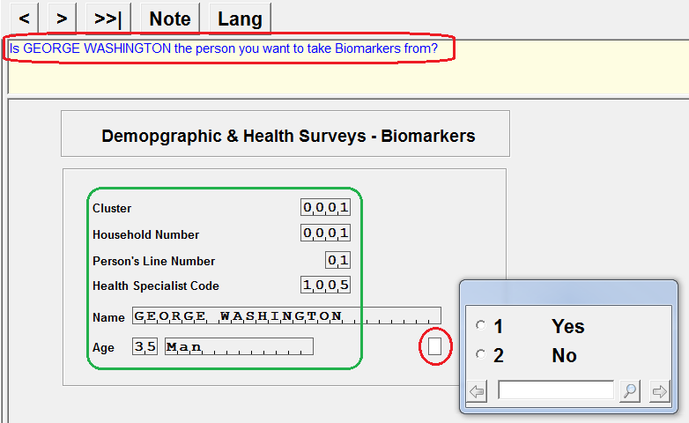

If the answer is **2-No,** the system dismisses the window and returns to the main menu. If the answer is **1-Yes**, the system displays the appropriate form (shown below) where biomarkers are to be registered. At this moment, the fields circled in green in the form below are pre-populated. The pre-populated fields correspond to question numbers in the biomarker questionnaire and they are different depending on whether Biomarkers are taken for children, women or men. The Biomarker data collection system includes several fields not defined in the biomarker questionnaire: XMINTD, XMINTM, and XMITNY. These fields correspond to the date (day, month, and year) when the first biomarker was registered for this individual. For women the field names are XWINTD, XWINTM, and XWINTY. For children they are XCINTD, XCINTM, and XCINTY. Biomarker forms also include the fields: “**Type of biomarker**”, “**Collect Anemia**”, “**Collect HIV**”, and “**Finalized**”. These are anchor fields used to define the type of biomarker to be taken at the time as well as to close the data collection of biomarkers for this individual.

After the health specialist confirms that the individual for which Biomarkers are to be taken is correct, the cursor positions itself in the auxiliary field with label **Type of biomarker**. At this point health specialists should decide what Biomarker are about to register for the individual. Depending on the code selected the cursor will skip to the appropriate panel in the form to record the data relevant to the biomarker.

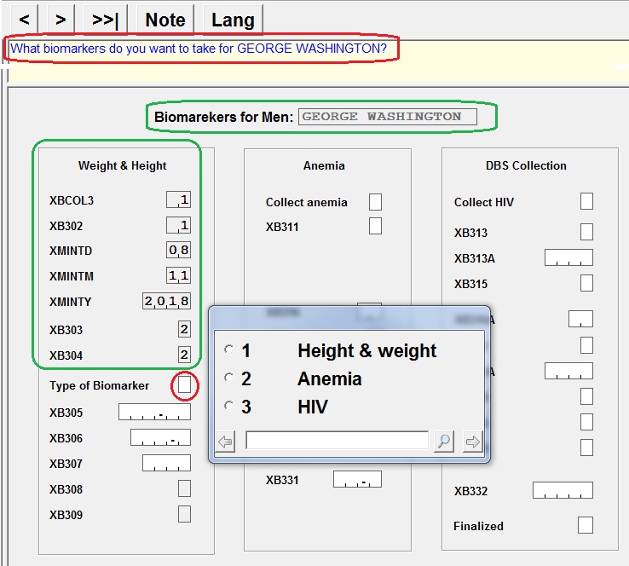

If the code selected is “**1-Height & weight**”, the system will proceed to request data to record the weight and height for the individual. After entering the information for this biomarker, the cursor stops in the field “**Collect anemia**” and prompts the health specialist if at that moment anemia should be taken.

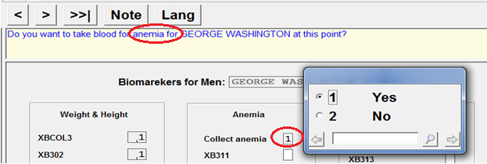

If the answer is “**1 Yes”** all data related for that biomarker including questions on consent for the test should be recorded. If the answer is “**2 No**” the cursor skips to the field with label “**Collect HIV**”. At that point, the same type of question is asked, but this time related to HIV.

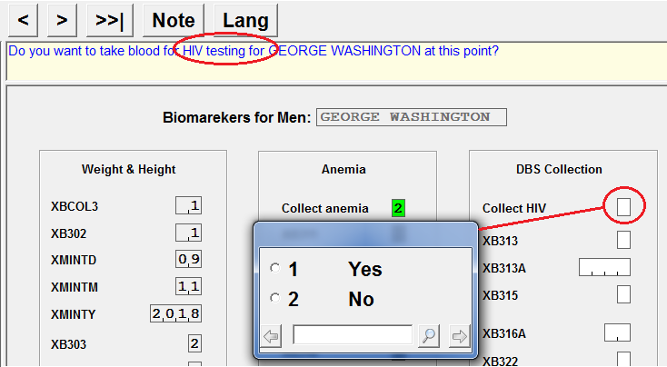

The same behavior as described for anemia is executed for HIV depending on the answer provided to this question. Finally, the cursor eventually reaches the field with the label “**Finalized**”.

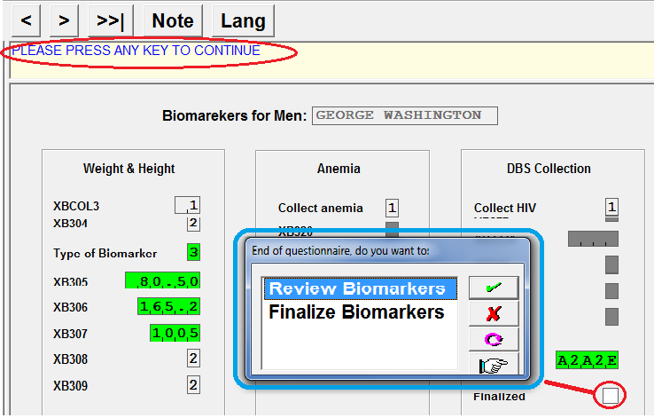

Once the cursor reaches the finalized field and after pressing the enter or spacebar keys on response to the instruction: “**Please press any key to continue**”; the system presents a window with options to “**Review Biomarkers**” or “**Finalize Biomarkers**”. If option “Review Biomarkers” is selected, the cursor remains in the finalized field and any field in the form can be modified if necessary (check how to move in a form in section **2.2.4 Field definition area** in the interviewer’s manual). If option “Finalize Biomarkers” is selected, the system dismisses the biomarker window and the data is automatically saved.

This type of data collection approach also applies to women and children. However, question numbers in their forms reflect the biomarker questionnaires for those sections. In the case of children, the date of birth is a very important piece of information and it is included in the biomarker questionnaire. That information is also collected in the birth history in the woman’s questionnaire. The system checks all women questionnaires for that household and if the child is declared as the daughter/son of one of them, it gets the date of birth and automatically populates those fields in the biomarker form. If the child is not found in any of the women’s birth histories, the system requests the health specialist to ask for that information.

## 1.8 Transferring biomarker data to supervisors

Health specialists must send the biomarker data they collect to supervisors on a regular basis and at least once a day. Normally the best time to do this is in the evening after all biomarker data for that day have been taken.

There are several reasons why this regular transfer is required, among them the most important are:

1. To ensure a safeguard of the biomarker data in the supervisor’s machine if the machine of the health specialist breaks down, is lost or stolen.
2. To provide the supervisor with the most recent information on the progress of the team work in the cluster. The supervisor is then able to determine what biomarkers are still outstanding for household members in the cluster.
3. To allow supervisors to review the biomarker data, in order to check their quality and completeness.

Option “**6 Transfer data to supervisors**” in the biomarker menu is designed to accomplish this task. Health specialists must wait until the supervisor has his/her machine in “receiving mode” before activating this option.

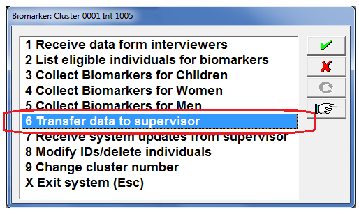

Once option 6 in the biomarker machine is selected, the system activates bluetooth and the health specialist machine start to search for the supervisor machine. When the supervisor machine is found the line where the supervisor name is displayed, changes from blank to green and the transmission takes place. The system then returns to the main menu.

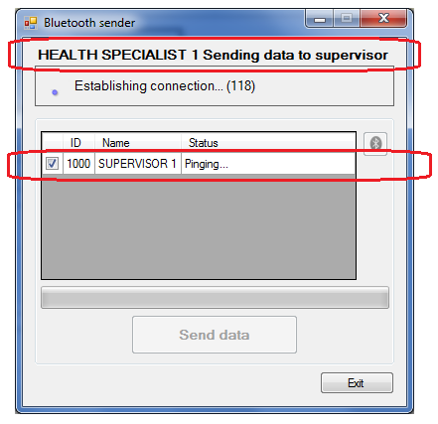

On the other hand, supervisors are provided in their system with the capability to get the data from health specialists. In order to do that, supervisors use option 3 in their menu.

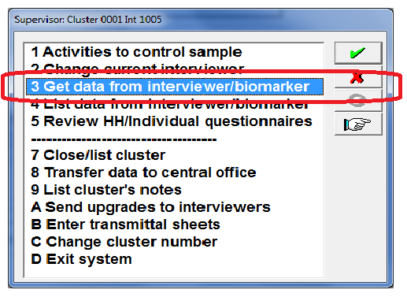

At that point, the supervisor machine launches Bluetooth in listening mode and waits until the biomarker machine finds it. As mentioned earlier, it is recommended that health specialists wait until the supervisor has his/her machine in “receiving mode” before they use the option to send the data.

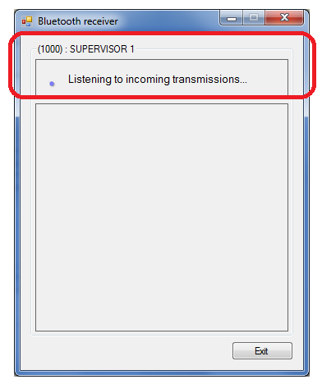

## 1.9 Receive system upgrades from supervisor

The system is provided with a mechanism to update the Biomarker data collection system while the fieldwork is in progress. Basically, applications or supporting data files need to be updated in the field. Applications may need to be updated to fix problems or for other unforeseen circumstances or events. Application supporting files (the ones described in the Introduction to CAPI elements in the interviewers’ manual) normally require updates for several reasons. For example, when a member of a team quits the job and a new one is hired. In this case the “Fieldwork personnel” file needs to be updated. Another example occurs if the household selection was not completed before the launching of the fieldwork. DHS developed the Internet File Streaming System (IFSS) to facilitate this operation. Through IFSS supervisors receive updates on their tablets and after updating their own machine they transfer the updates to the interviewers.

The process for receiving updates from the supervisor is similar to that of receiving household data from interviewers, but instead of pairing the biomarker machine with the interviewers it is done with the supervisor. Updates can be transferred to health specialists and interviewers at the same time. In order to get the upgrades, follow these steps:

From the Biomarker menu select option “**7-Receive system updates from supervisor**”

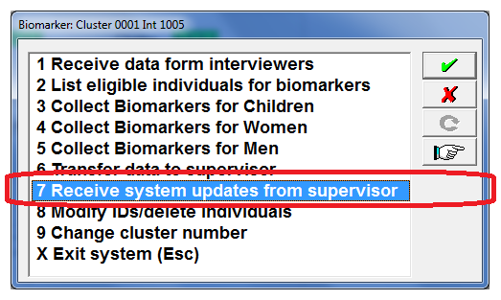

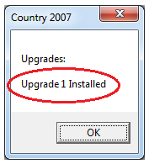After selecting option 7, the Biomarker machine enters in listening mode waiting for the update to arrive. The CAPI system keeps track of what updates are installed in every machine. When an update is received the system automatically installs it in the machine and displays a message to that effect. It is possible to receive several updates at a time. If that is the case, the system installs the updates in the order that they were sent therefore preventing to override modifications to files where sent more than one time.

After the installation takes place, a message is displayed specifying that the system will shut down to allow the upgrades to take effect. Click “OK” on the message and the Biomarker data collection system is terminated. Double click on the health specialist icon to start the data collection system again.

## 1.10 Modify identifiers or delete individuals

Sometimes it is necessary to make corrections to identification fields or to health specialist codes. Identification fields uniquely identify individuals. Health specialist codes are also used to give names to the files where the data is stored. The identification fields are the cluster number, the household number and the line of the household member in the household schedule. The health specialist code corresponds to the code assigned to every fieldwork participant by the survey management. There are several reasons where this capability is required by the system.

* When for some reason the cluster number, household number or line number of the individual changed in the interviewer’s machine
* As a result of an oversight on the part of the health specialist when the biomarker data was not registered for the intended person
* In a typical DHS survey, only one health specialist is assigned to a fieldwork team, but there is nothing that prevents to have more than one. When that occurs, there is a possibility of duplicates and if that is the case one of the duplicates has to be deleted.

It is not possible to make these corrections directly using the Biomarker data collection applications. Instead, these corrections and/or deletions are carried out using an especial utility called “Data repair” designed by DHS for this purpose.

To access the Data Repair utility, from the Biomarker menu select option “**8-ModifyIds/delete individuals**”

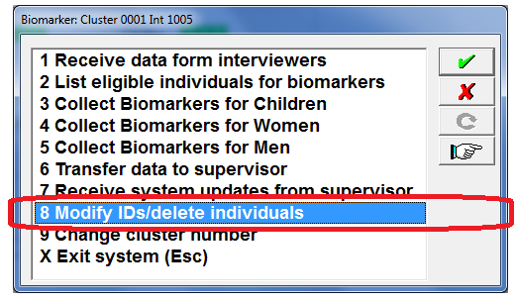

Before modifying Biomarker identification fields or health specialist codes, it is important to know the values of the identification fields or the health specialist code to be modified. This information should be known for both the individual that needs to be modified and the individual where the modification is to be implemented. If the operation to be performed is to delete an individual, then destination is not relevant. Essentially the values (codes) for the following fields are needed.

1. Cluster number
2. Household number
3. Respondent line number (if modifying /deleting an individual questionnaire)
4. Biomarker code.

After selecting option “8-Modify IDs/delete individuals”, the Biomarker data collection system displays the Data Repair interface:

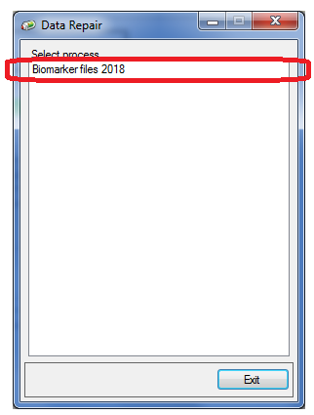

Click on the “Biomarker files 2018” tittle. Subsequently, the interface displays a window with boxes to enter Cluster, Household number, line number of the individual, and Biomarker code (as shown below). It is important to note that since the identifiers are numbers they don’t need to be padded with zeros on the left. The data repair interprets the same numbers typed as “0001” or just “1”. After filling-in all fields click on the  button when the modification to be done is to change one of the fields displayed. Click on the  button if the household or individual needs to be deleted. Click on the  button to go back to the previous screen with no further action needed.

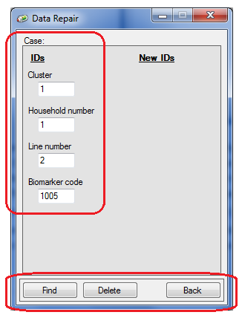

If the find button is selected “Data Repair” retrieves the questionnaire from the file where it is stored. If the individual is successfully found, a new a new window is displayed with a mirror of the fields that can be potentially changed. Mark the field to be changed and type the new ID that the modified individual will take. In the example below the household number will be changed from 1 to 5. It is possible to change several fields at the same time.

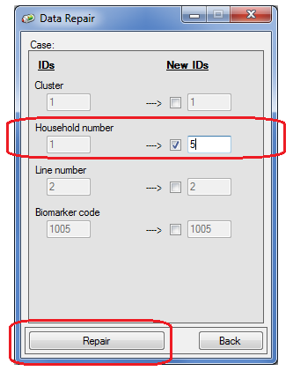



Once the modified fields are keyed, click on the button for the modification to take place. After the Data Repair is successfully executed, the following message is displayed:

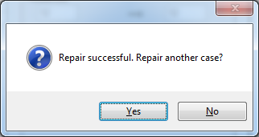

To verify that the modification was done properly, generate a report using option **“2-List of eligible individuals for biomarkers”** from the menu as described earlier.

## 1.10 Changing cluster number and exiting the system

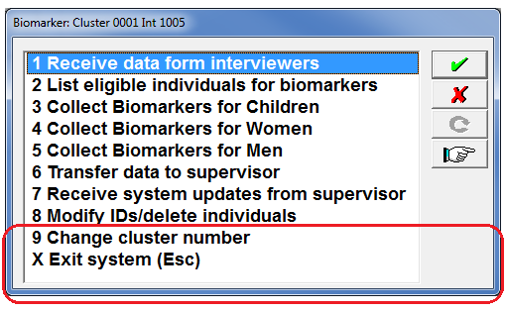

Option “**9-Change cluster number**” is self-explanatory. Most of the times a cluster number is changed when login into the system. However, if for some reason health specialists are working or reviewing data from two different clusters they can use this option to switch among clusters without having to leave the system.

Option “**X-Exit system (Esc)**” as implied by its tittle should be used to exit the Biomarker data collection system. The **(Esc)** characters included as part of the option tittle, indicate that that alternatively the escape key can also be used to exit the system. Always use this option to exit the data collection system. This option should also be used if the system is not expected to be used for an extended period (15 or more 15 minutes, for example). If for some reason the menu is terminated in any other way, the message shown below is displayed upon login again into the system. The reason for the message is to prevent that two instances of the application are launched concurrently. When the application exits properly, the system removes any traces left by the data collection session, essentially implying that is ready to start another session.

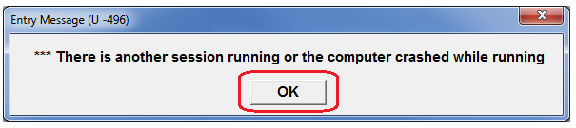

After dismissing the message with the OK button, the system displays a window to reset the traces left by the previous session or to quit the current instance of the session. If the previous session was not correctly closed, select **Yes** and the system will proceed properly. If another instance of the Biomarker data collection was launched by mistake, select **No**. When No is selected the system closes the current session and health specialists can continue with the former active session.

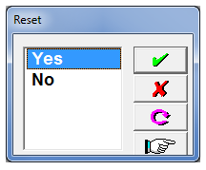

# COLLECTING BIOMARKER USING PAPER QUESTIONNAIRES

## Introduction

Biomarker data can also be manually registered on paper questionnaires. With this model, after interviewers complete a household questionnaire, they use one of the options in their data collection menu to report the eligible individuals in the household for biomarkers. Interviewers use this report to manually prefill several pieces of information in the biomarker questionnaire. Essentially, all pieces of information that health specialists may need to identify individuals to be measured/tested (see section 2.3) in the household are prefilled by interviewers. Subsequently, Interviewers hand over the paper questionnaire to the health specialist designated to collect biomarkers for team. The health specialist contacts the eligible individuals and completes all relevant data for each biomarker. Once health specialists collect all biomarkers for all eligible members in the household, they hand back the biomarker questionnaire to the interviewer that initially gave her/him the questionnaire.

## Entering biomarker questionnaires

With the biomarker questionnaire in hand, interviewers proceed to enter the questionnaire. Essentially, they key in the answers from the paper questionnaire to the tablet. To carry out this process from the **Main Menu** interviewsselect option **“5**-**Enter biomarker data”.** After selecting option 5 a list of households is displayed in the same manner as described in section 5.1 of the interviewers’ manual.

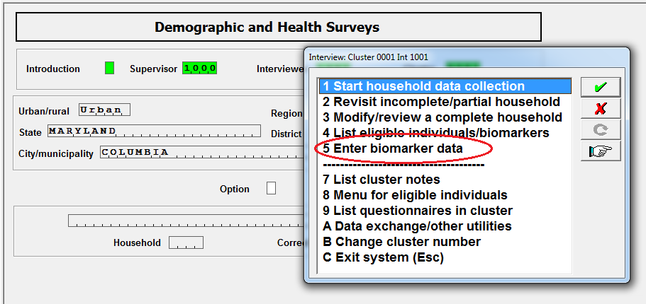

The list of households to select consists of households assigned to the interviewer by the supervisor. Note that if you had completed a household that was “assigned to someone else”, or “a new household not originally in the sample”, then the assignment file is rewritten and these households now become as if they were “assigned to you”.

Select the household and confirm that this is indeed the household for which you want to enter the biomarker data. If there are eligible individuals for biomarkers (children age 0-5, women or men) in the household roster, then the section to register the date of the biomarker visit is displayed. The biomarker questionnaire varies from survey to survey depending on the type of biomarkers that are collected (anemia, HIV, malaria, etc.) and the target people (children, women and/or men).

The figure below shows that the total number of eligible women and men for biomarkers is already pre-populated. This is because the eligible women and men were determined after collecting the household roster. The number of children eligible for biomarkers is determined after the number of visits is entered.

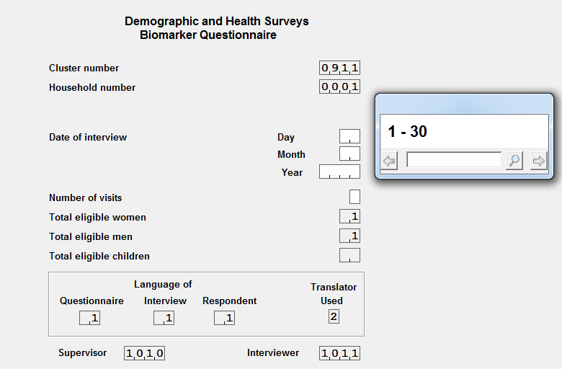

Enter the date of the biomarker visit and the number of visits. Next the section for “Weight, Height and Hemoglobin measurement for children age 0-5” is displayed.

Note that in the questions area the name of the child for whom the biomarker data is being entered is displayed. This helps to properly enter the information as it is possible that the health specialist may have changed the position of the children (women or men) when collecting the data. The biomarker form is displayed in tabular format. Every column corresponds to an eligible child from the household, in the order of their appearance in the household roster. After entering the information for the first child, the system automatically places the cursor in the column for the next child.

If there are eligible women age 15-49 or eligible men age 15-54[9] listed in the household roster, then the sections for “Weight, Height, Hemoglobin measurement and HIV testing form women age 15-49” and “HIV testing for men age 15-54[9]” are displayed immediately after completing the section for children. First the form for women is displayed and then the form for men. Within each form the eligible individuals are displayed in the same order as they were listed in the household roster.

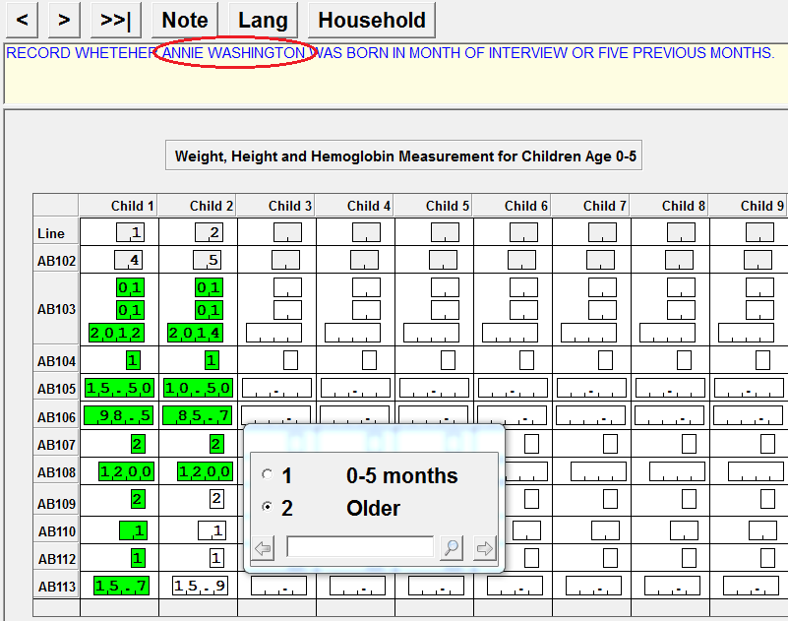

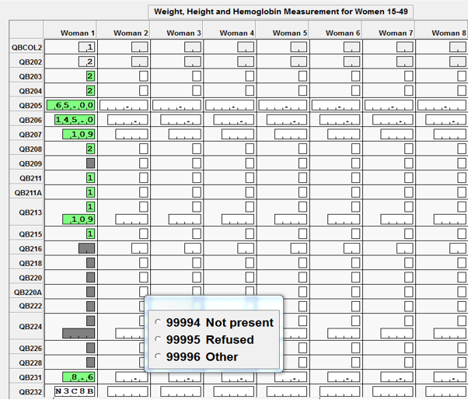

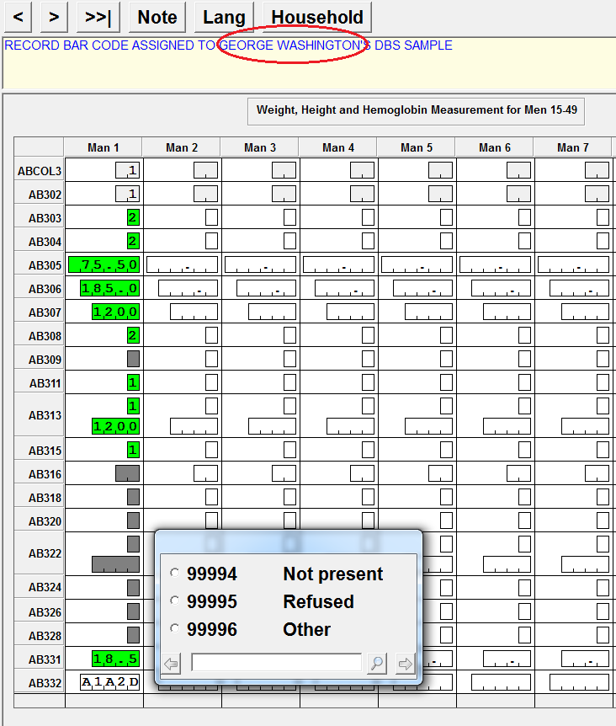

## List eligible individuals/Biomarkers

This option is used to display all individuals identified in the household who are eligible for individual questionnaires and biomarkers. To produce this report, from the interviewer’s main menu just select option “**4-List eligible individuals/Biomarkers**” and then **Select a household.** After selecting option 4 from the main menu a pop-up box shows-up asking to select the household for which the list of eligible individuals is required. Select the household by highlighting it with the up and down arrow keys or with the stylus and tap the enter key or click on the  button. After those steps are carried out, an application to list those eligible individuals is launched and a CSPro program called “Text Viewer” is used to display the report in the screen. As can be seen below the report lists for the selected household first all eligible persons for Individual interviews. It then lists all children eligible for biomarkers followed by women and men eligible for Biomarkers.

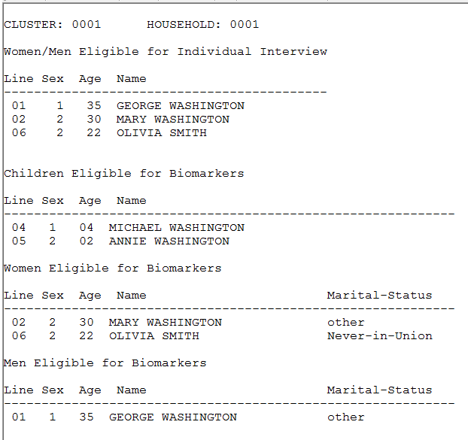

This report should be produced immediately after completing a household as it is mainly used for two purposes: The first one is to know if the household data needs to be shared with other team members. This happens when the household was collected by a female interviewer and there are men eligible for individual interviews or the other way around. The second purpose is to write down in the biomarker questionnaire all the information needed by health specialists to identify individuals for which biomarker samples are required. The cluster number and household number should be written down in the cover page of the biomarker questionnaire to identify the household. For each eligible individual in the appropriate biomarker form (children/women/men), line numbers and names need to be written. For children the date of birth from the mother (if eligible) should also be provided. For adults the age (15-17, 18+) and marital status should be provided in order to know if the individual is emancipated or not. It is very important to write down this information in order according to the line number within the form. Essentially, it should be written by line number within the form in the same the way it is displayed in the report. In the report above there are four eligible individuals for biomarkers, two children, one woman and one man. In the children paper biomarker form the first column should be used to record information for Michael Washington which is line 4. In the second column the information for Annie Washington should be recorded. In the woman’s form, only the information for Mary Washington should be recorded. Finally, in the man’s form the information for George Washington should be recorded.

To meet the requirements described in the previous paragraph, both the list of eligible persons for individual interviews, and the list of eligible persons for Biomarkers are shown in one single report. Note that all information (except for the child’s date of birth) required according to the previous paragraph is included in this report. If a person is eligible for the individual and biomarker questionnaires, he/she will be listed in both sections of the report. There may be cases where there are no eligible women/men for the individual interview or children/women/men for biomarker data collection.

# COLLECTING BIOMARKER DATA BY INTERVIEWERS

## Introduction

With this approach, the same interviewer that collects the household questionnaire collects the biomarker data. Biomarker data is entered concurrently when measurements or tests are taken. Biomarker data can only be collected in the same computer where the household questionnaire was collected. Biomarker data can only be collected in households successfully interviewed and of course when there are eligible individuals for biomarkers in the household. However, it is not necessary that the data for biomarkers is collected immediately after the household is completed. Biomarkers can be collected at any time after the household questionnaire is completed.

This approach has been used in a few DHS surveys and in general works well when there is only one or a maximum of two biomarkers to be collected. It is also important to keep in mind that the interviewer should be qualified to measure or collect the specific biomarker specimens. In the few surveys where this approach has been used only height and weight and/or hemoglobin have been collected.

Basically, this method works in a similar manner than the method used when paper questionnaires for biomarkers are used (see previous section). The main difference is that contrary to the paper based, biomarkers can be collected in any order.

## List eligible individuals/Biomarkers

After completing a household questionnaire, interviewers can use option “**4-List eligible individuals/biomarkers**” in the main menu to display a report listing the individuals eligible for biomarkers.

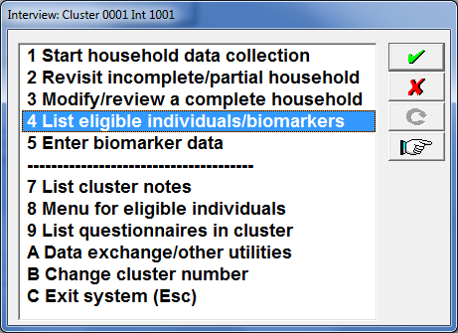

After selecting option 4, interviewers are requested to select the completed household in the cluster where biomarkers need to be identified. The purpose of this report is to provide interviewers with names and other characteristics of children, women and men eligible for biomarkers. Based on the report interviewers contact or make appointments with the corresponding individuals to take the appropriate biomarkers. One advantage of this model is that biomarkers can be taken immediately after completing the household questionnaire.

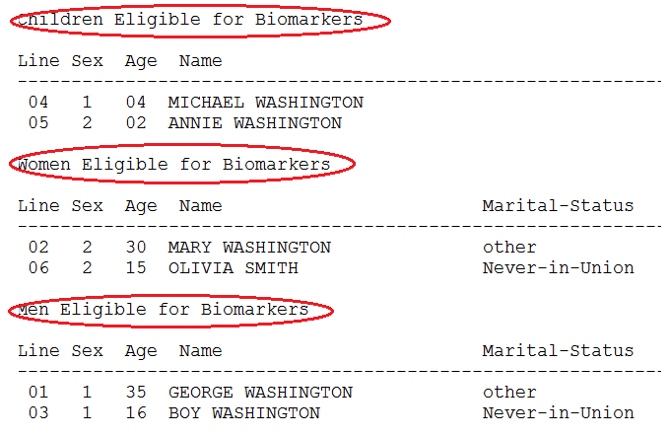

## Entering biomarker data

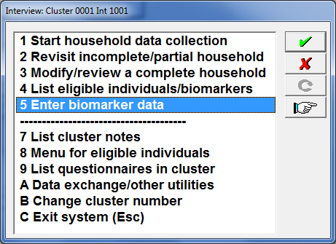

After contact is established, interviewers prepare the equipment required to collect the biomarkers. Once they are ready to take the biomarkers interviewers use option “**5-Enter biomarker data**” in the main menu to record the biomarker result.

After option 5 is selected, the application positions itself on the cover page of the biomarker questionnaire to register the date of the visit and the number of visits. All other fields in cover page of the questionnaire are automatically populated by the system.

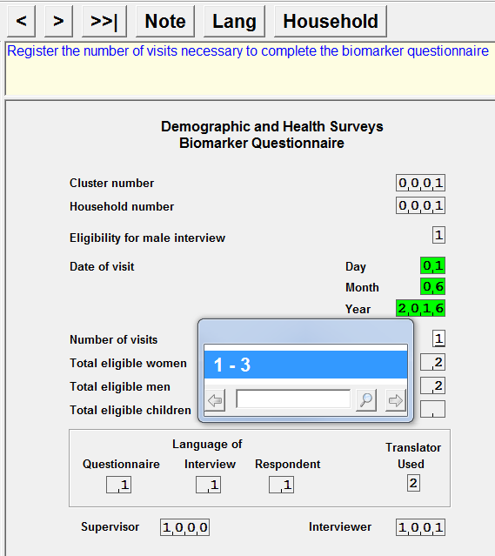

Once fields in the cover page of the biomarker questionnaire are filled in, the application goes to the field ACAUXIL to ask whether this is the individual for which biomarkers are going to be taken. If the response to that question is “1-Yes”, the system requests input for the biomarkers for that individual. If the response is “2-No” the system goes to the next individual to ask the same question. The figure below shows that the answer for the first child was negative (No), but it was positive (Yes) for the second.

The system knows in advance what individuals are eligible and only asks information for them. For example, if there are no children eligible in the household, the system skips the section for children and start asking the relevant questions for either women or men. Biomarkers are requested to be entered in the same order as defined by the line number of the household member in the household schedule. However, as mentioned earlier the biomarker information for any individual can be entered at any time.

When collecting biomarkers for children, the child’s date of birth is required. The child’s date of birth is also collected as part of the birth history in the woman’s questionnaire. The system searches across all women interviewed for the household and if the child is declared as the daughter/son in the birth history for any of these women, the system brings that date and populates the corresponding fields in the biomarker questionnaire.

